LOCAL ELECTION RESULTS

FROM MOLESEY RESIDENTS ASSOCIATION

MOLESEY EAST (TURNOUT 43%)

FLATAU, RICHARD – LIBERAL DEMOCRAT 1236 ELECTED
GORMLEY, PAT – MOLESEY RESIDENTS 920
RENDALL, ROSIE – LABOUR PARTY 129
ZHAO, CHEN – CONSERVATIVE PARTY 615

MOLESEY WEST (TURNOUT 32.8%)

AJJANE, JAMAL – LABOUR PARY 143
FUCHS, AGNES – CONSERVATIVE PARTY 384
NAGEL, PAUL – LIBERAL DEMOCRAT 701
POPHAM, TONY – MOLESEY RESIDENTS 927 ELECTED

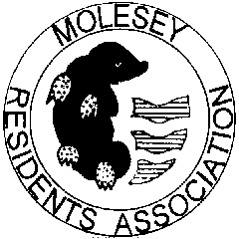
--------------------------------------------------------------------
MOLESEY RESIDENTS ASSOCIATION
WOULD LIKE TO THANK ALL THOSE
WHO SUPPORTED THEIR MRA CANDIDATES.

Printed and Published by Molesey Residents Association 20, Walton Road, East Molesey KT8 0DQ

